*Session 1: Assignment 1*

1. Install Jupyter notebook and run the first program and share the screenshot of the output.

Solution : Jupyter Screenshot

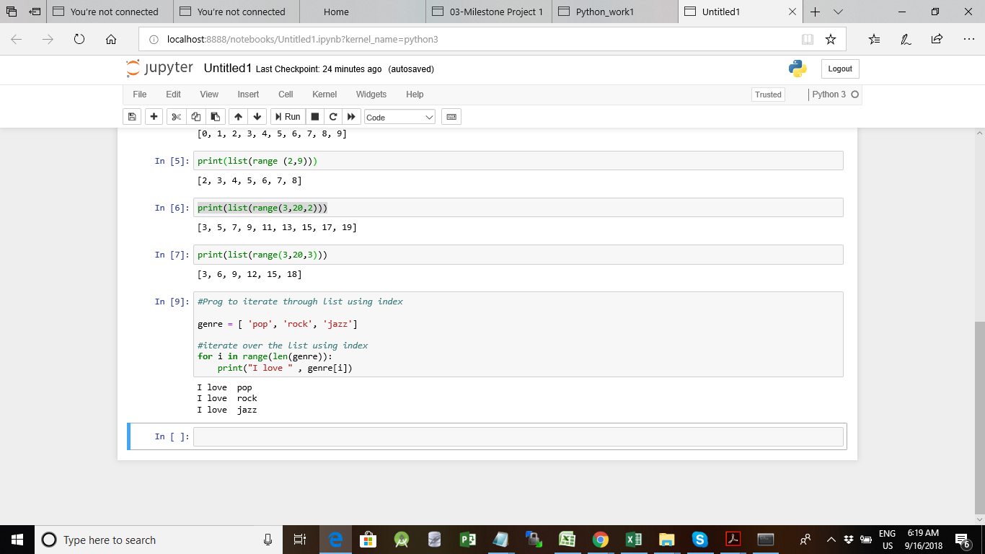

**Task 1**

1. Write a program which will find all such numbers which are divisible by 7 but are not a multiple of 5, between 2000 and 3200 (both included). The numbers obtained should be printed in a comma-separated sequence on a single line.

**Solution:**

#Prog to find all numbers divisible by 7 and not by 5 within a range

x=list()

for i in list(range(2000,3201)) :

if ((i%7 == 0) ):

if( i%5 != 0) :

x.append(i)

print(x)

**Screenshot Below:**

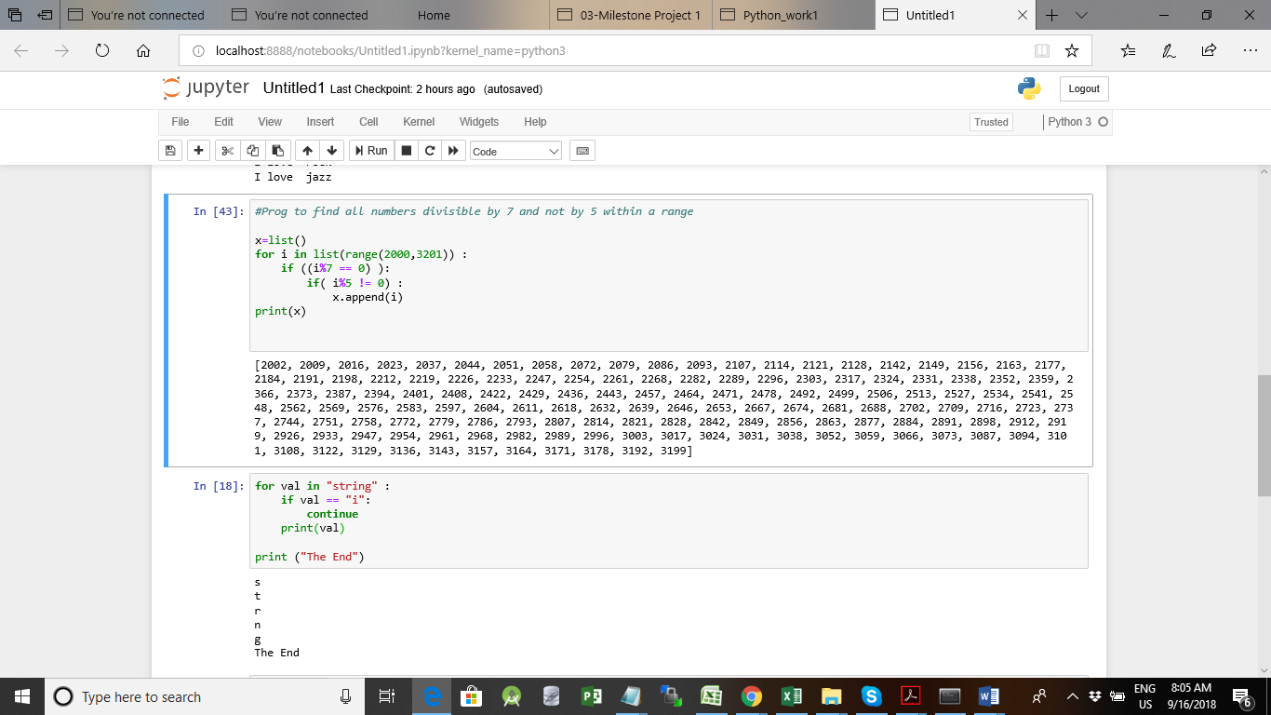

1. Write a Python program to accept the user's first and last name and then getting them printed in the the reverse order with a space between first name and last name.

**Solution:**

fname=input("Whats your First Name?")

lname=input("Whats your Last Name?")

print(fname[::-1]+ " "+ lname[::-1])

Screenshot Below

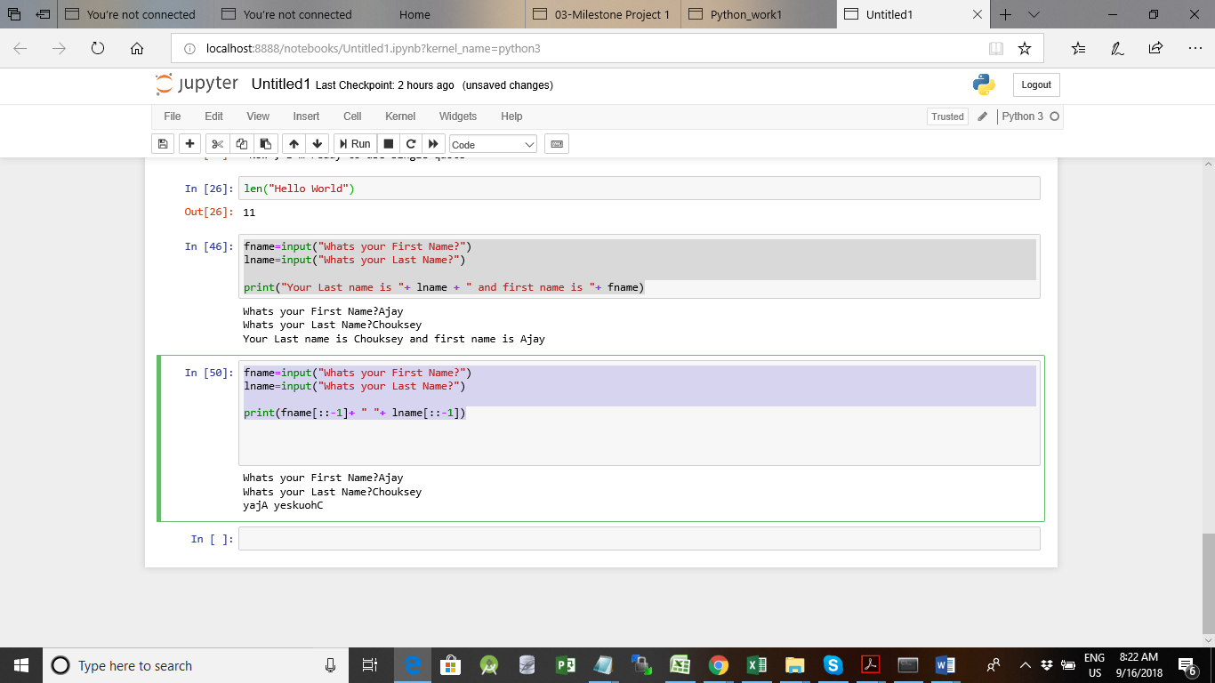

1. Write a Python program to find the volume of a sphere with diameter 12 cm.

Formula: V=4/3 * π * r 3

R=12/2=6

v= (4/3)*(22/7)*6**3

print(v)

**Screenshot Below**

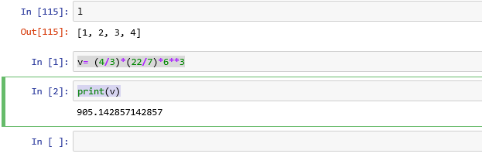

**Task 2:**

1. Write a program which accepts a sequence of comma-separated numbers from console and generate a list.

Solution:

nums = input("Enter comma separated numbers: ").split(',')

print(nums)

Screenshot Below:

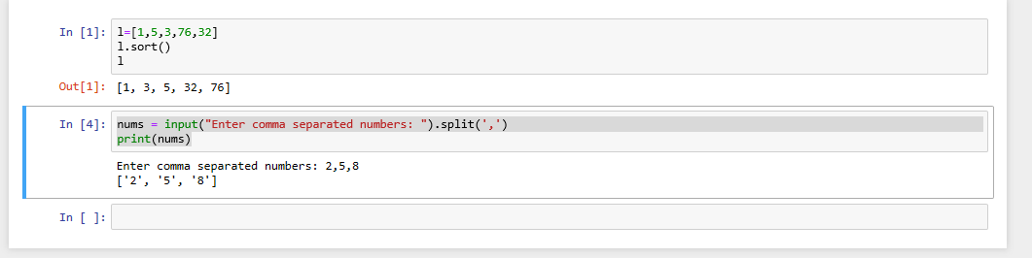

1. Create the below pattern using nested for loop in Python

*

* *

* * *

* * * *

* * * * *

* * * *

* * *

* *

*

Solution :

#Program to print star shape

list=[1,2,3,4,5,4,3,2,1]

star='*'

for i in list :

print(star*i)

Screenshot Below:

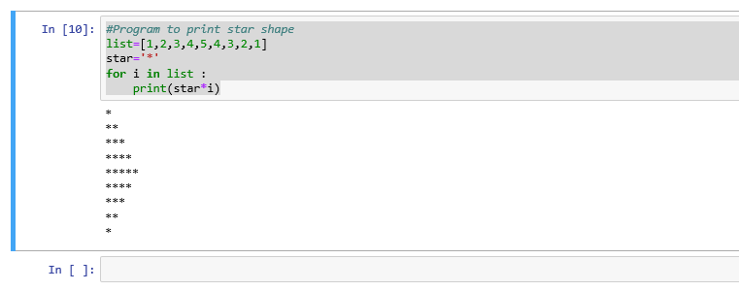

1. Write a Python program to reverse a word after accepting the input from the user.

**Sample Output:**

Input word: AcadGild

Output: dilGdacA

Solution:

name=input()

print(name[::-1])

ScreenShot Below:

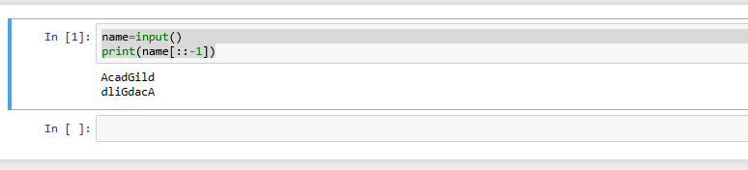

1. Write a Python Program to print the given string in the format specified in the sample output.

WE, THE PEOPLE OF INDIA, having solemnly resolved to constitute India into a

SOVEREIGN, SOCIALIST, SECULAR, DEMOCRATIC REPUBLIC and to secure to all

its citizens

**Sample Output:**

WE, THE PEOPLE OF INDIA,

having solemnly resolved to constitute India into a SOVEREIGN, !

SOCIALIST, SECULAR, DEMOCRATIC REPUBLIC

and to secure to all its citizens

Solution:

print("WE, THE PEOPLE OF INDIA,\n\t having solemnly resolved to constitute India into a SOVEREIGN,\n\t\t SOCIALIST, SECULAR, DEMOCRATIC REPUBLIC\n\t\t and to secure to all its citizens")

Screenshot Below

